Low-Cost Expendable Buoys for Under Ice Data Collection
DRUID Buoy: Delayed Release Under-Ice Drifter Buoy (maybe?)

D. Langis, P. J Stabeno, and C. Meinig
Pacific Marine Environmental Laboratory
National Oceanic and Atmospheric Administration
Seattle, WA
Daniel.P.Langis@NOAA.gov
Phyllis.Stabeno@NOAA.gov
Christian.Meinig@NOAA.gov
C.W. Mordy and H. M. Tabisola
Joint Institute for the Study of Atmosphere and Ocean
University of Washington, and
Pacific Marine Environmental Laboratory
Seattle, WA
Calvin.W.Mordy@NOAA.gov
Heather.Tabisola@NOAA.gov

Abstract— Conditions directly under Arctic sea ice during spring and early summer months are largely a mystery, but it is clear that` they play a critical role in shaping one of the world’s most highly productive ecosystems. The Pacific Marine Environmental Lab (PMEL) has designed a new, low-cost, expendable under-ice buoy capable of collecting oceanographic data at the water-ice boundary to address gaps in knowledge during these critical periods. Preliminary versions of the instrument were deployed in the Chukchi Sea in 2015 (Generation 1) and Bering Sea in 2017 (Generation 2), collecting data on temperature, depth, and PAR (Photosynthetically Active Radiation). These deployments successfully demonstrated the viability of the low-cost design, its robust nature, and its ability to provide high-quality data. Opportunities for future development (Generation 3) include measurement of fluorescence and collection of daily images for situational awareness and to assess the abundance of ice-associated algae. Onboard GPS provides precise location data from open water and all data are transmitted to shore using Iridium Short Burst Data (Generations 2 and 3). These compact instruments are optimized for use in the relatively shallow waters of the Arctic continental shelf. Their cost advantages can be best leveraged to provide improved spatial coverage over this enormous area, where observations are typically sparse. These under ice buoys are one of several new technologies in development by the Innovative Technology for Arctic Exploration (ITAE). Collectively, they represent a unique opportunity to improve the basic understanding of the changing Arctic environment and to cost-effectively monitor future changes.
Keywords—Arctic, sea ice, ecosystem monitoring, low-cost instrumentation, technology development, ITAE

Introduction

Need for under-ice measurements
Massive phytoplankton blooms have been identified under Arctic sea ice (Arrigo et al., 2012), but the prevalence of such events and their impact on ocean ecology and carbon fixation is unknown (Horvat et al., 2017). Additionally, the character of the ice edge environment is changing with the loss of multiyear sea ice and overall thinning of the ice matrix, and this has complex implications for the physical and chemical systems and the attendant food web.
The remote and harsh conditions in the Arctic make data collection under sea ice notoriously difficult. Large ice keels, constantly shifting floes, and broad inaccessibility make
data collection under sea ice notoriously difficult. Other forms of technology cannot access the under ice regime or are prohibitively expensive.

Functional Requirements for an Under Ice Buoy
-Highly Robust
-Low-cost and/or recoverable data (risk of instrument loss)
-Must access regime directly under ice
-Must provide high quality data

Generation 1: Satellite Tag Prototype
Identify applicable sponsor/s here. If no sponsors, delete this text box (sponsors).
Prototype of under ice buoy made using satellite tags to measure, record, and telemeter data. Satellite tags themselves met several of the basic design requirements for an under ice buoy. They are robust (normally used on marine mammals in dynamic environments) and can measure, record, and telemeter high quality data without needing to be recovered. Satellite tags from the University of St. Andrews Sea Mammal Research Unit were selected because of their ability to provide high accuracy data (+/- 0.01°C temperature, other specs, etc.) and for SMRU’s ability to modify the sampling schedule for PMEL’s under ice buoy application.
Two prototype buoys were deployed from the USCGC Healy in July 2015 in the Chukchi Sea. The ship was in approximately 9/10 ice coverage 20-40nm from the ice-edge. The prototype buoys were designed to anchor on the bottom for a few days before releasing the float under ice, collecting a profile on the way to the surface. They would then measure conditions under the melting ice pack for a relatively short period of days or weeks and transmit data to shore. This deployment was designed to test the feasibility of the delayed release concept, quality of satellite transmitted data, and survivability of the buoys under ice.
The satellite tags were each attached to a trawl float for floatation, which was covered by a ‘hard-hat’ shell for physical protection, and fitted with a counterweight to keep the buoy upright. The floatation unit was rigged to an anchor, drop weight and two galvanic timed releases. After the units were deployed, the lower, primary release would corrode after a few days to release the unit from the seafloor. After several more days, the upper, secondary release would corrode, making the buoy more positively buoyant and providing extra freeboard to facilitate data transmission after emerging from the ice.
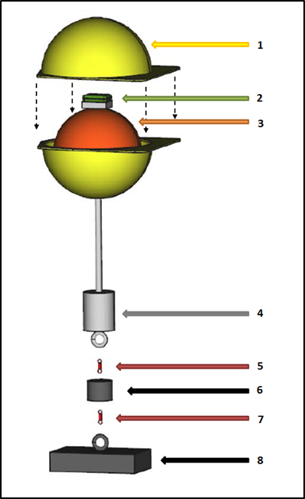
- Schematic of Under Ice Buoy Prototype. (1) ‘Hard hat’ casing. (2) Satellite tag. (3) Trawl float. (4) Counter-weight. (5) Secondary Release. (6) Drop weight. (7) Primary Release. (8) Anchor
The first of the two buoys worked as expected, remaining under ice for approximately 4 days before emerging from ice and successfully transmitting all data to shore. The temperature warmed slightly, from x.xx°C to x.xx°C, and PAR increasing steadily, from a peak daily value of yyy umol to yyy umol over this period, implying freshening water and thinning ice.
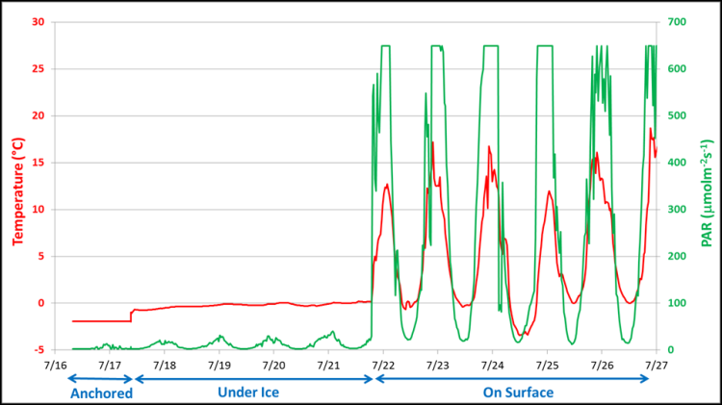
The second buoy did not transmit data as expected, but instead transmitted data 13 months after deployment, approximately zzz nm from the deployment location, likely due to a scheduling error. Although data from the second buoy are inconclusive, the spherical design and protected antenna proved to be incredibly robust, as the buoy survived a full year directly under ice in the Chukchi Sea.

Generation 2: In-House Built

Design
The prototype was successful in meeting the basic design requirements of an under ice buoy, but had several drawbacks. Satellite tags were shown to be an effective method of recording and transmitting data, but were prohibitively expensive to use for expendable instruments ($4,300 for each tag alone). The compact design of satellite tags, while advantageous for marine mammal applications, limited the available power, endurance, and potential sensors when evaluating long-term (1+ year) under ice applications. Due to the lack of other commercial alternatives, researchers at PMEL designed a custom low-cost instrument, capable of making under-ice measurements.
The second generation of under ice buoy was equipped with depth, temperature, PAR, and tilt sensors, as well as GPS and Iridium Short Burst Data (SBD) modules. A number of cost‐saving design features were integrated to achieve a cost per instrument of under $3,000. Features included low‐cost pressure housings, commercial off‐the‐shelf (COTS) components, and custom analog-to-digital circuitry for sensors.
Although low-cost, the floats provided high‐quality data - measuring temperature to ± 0.01°C accuracy, depth to ± 0.21m accuracy, and PAR to ± 3% accuracy.
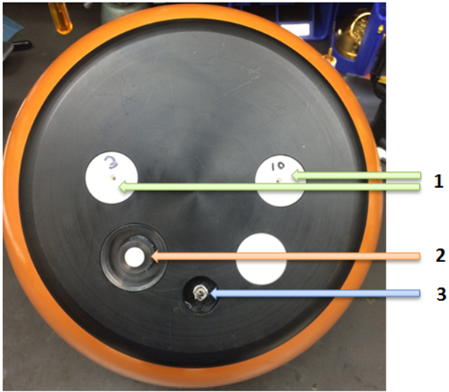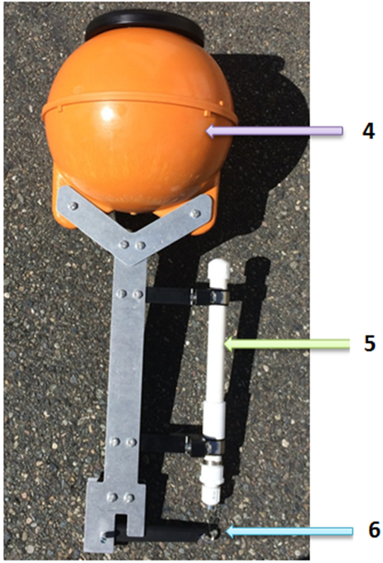
- Left – Under-Ice Buoy as viewed from above (1) Pressure Sensors. (2) PAR Sensor. (3) Temperature Sensors. GPS and Iridium Antennas are embedded under the cap to prevent them from being damaged by ice. Right - Under-Ice Buoy as viewed from side. (4) Pressure housing (5) “Burn wire” timed release. (6) Load-reducing mechanism. Diameter of housing is 34 cm and height from top of buoy to bottom of frame is 90 cm.
- List of major components for generation 2
Component(s)ª | Cost^{b} | Details and Specifications
Trawl Float (Pressure Housing) | $33 | 12” ABS Trawl Float  27.5 lb. nominal buoyancy
PAR Sensor | $364 | Skye Instruments TAG-PARQ Sensor  ±3% accuracy, 0 to 2000 μmol/m²s
Temperature Sensor | $10 | Custom NTC Thermistor Probe  ±0.01°C accuracy, -5°C to +70°C
Pressure Sensors | $125 ea | Two Keller PA-4LD Pressure Sensors  4.5cm accuracy (at 0°C), 0 to 30/100m
Iridium Module  and Antenna | $330 | RockSeven RockBLOCK Mk2  Iridium 9602 Module
Burn Wire Release | $165 | Sub-Sea Sonics TR-45 Timed Release  40 lb. Max. Load, 170 Day Max. Time
Micro-Controller | $38 | Arduino MEGA 2650
Battery Pack | $56 | Custom 9V, 28A-h Alkaline Pack
GPS Module  and Antenna | $35 | Alpha Micro PA6H Module
PCB Assembly | $350 | Custom PCB Assembly
Mechanical Assembly | $1,000 | Custom Machining for Load-Reducing Mechanism and Sensor Integration
- Only major components listed
- Costs Approximate

2017 Deployment
In September 2017, five Generation 2 under ice buoys were deployed in the Bering Sea approximately xx.x nm Southeast of St. Matthews Island in 70m of water. The buoys were programmed with release dates between February 20 and March 15, 2018, as this is close to the timing of annual maximum ice-extent. The expectation was that the instruments would surface under thin first-year ice, flow southward with the advection of ice and emerge from the ice pack within several weeks. Unfortunately, for the first time since 19xx, there was no ice at the deployment site during winter. In fact, the most notable aspect of the 2017 to 2018 winter ice extent was the persistently low ice extent in the Bering Sea^{ref}.
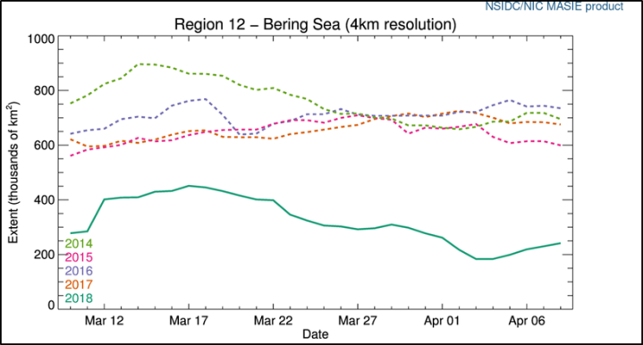
Due to the absence of ice at the site, four of the five instruments surfaced in open water. (One instrument never transmitted, likely due to a mechanical failure.)
All four buoys transmitted complete data sets in open water in 5-8 ft+ seas.
Bottom temperature:
- All buoys show close agreement with each other
- Typical seasonal dynamics
Temperature Profiles:
- Well mixed March 1, intrustion of warm water into lower water column by March 10.
PAR:
- Typical profiles and daily variation when on surface.
- No light on bottom as expected
Lessons learned
- Overall very successful
- Temp and PAR data look very good
- Iridium SBD works well, even in open water with moderate to heavy sea state
- Independent release timing worked well
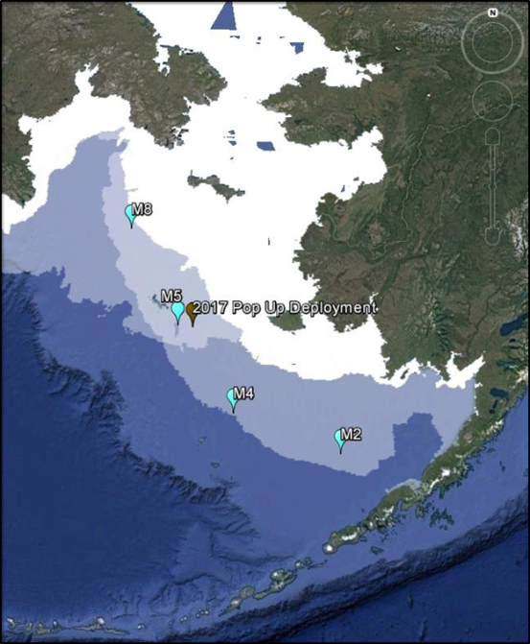
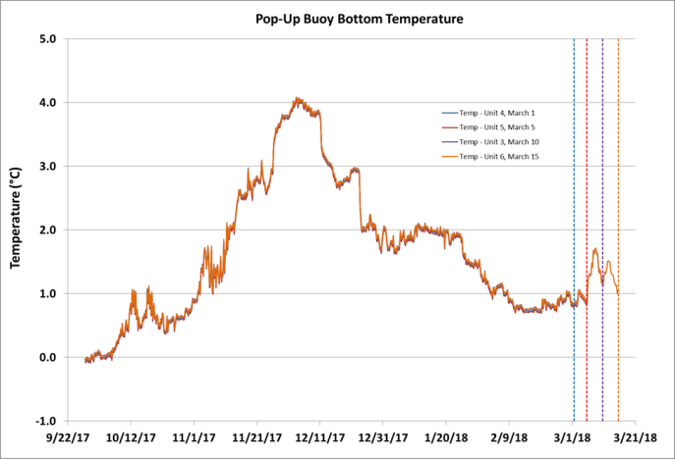
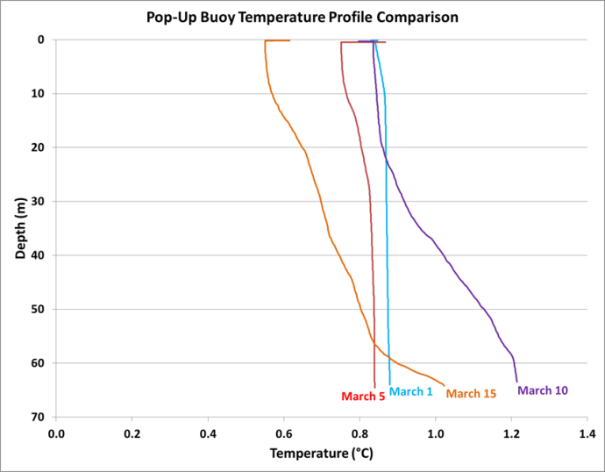

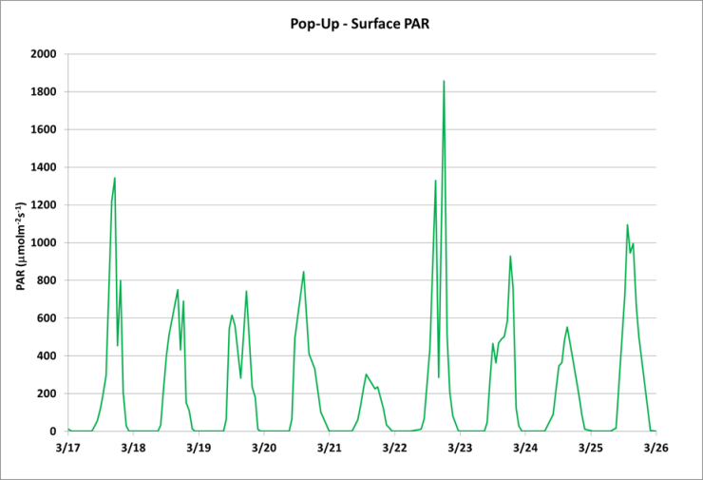

Generation 3: On-going/future development

Design Improvements
Addition of Sea Surface Temperature Probe
- Possible because data transmission worked extremely well once buoy was in open water.
- Potential use for meteorological reporting/inclusion in global drifter datasets
- Potential use for heat budget and energy transfer in Arctic?
Fluorometer
- Extremely important to collect information on abundance and frequency of phytoplankton blooms under ice
Camera
We suggest that you use a text box to insert a graphic (which is ideally a 300 dpi TIFF or EPS file, with all fonts embedded) because, in an MSW document, this method is somewhat more stable than directly inserting a picture.
To have non-visible rules on your frame, use the MSWord “Format” pull-down menu, select Text Box > Colors and Lines to choose No Fill and No Line.
- Low cost, JPEG compression camera module
- Situational Awareness, assess character/quality of ice, assess changes in water color, assess ice-associated algae
- List of major components for generation 2

Component(s)ª | Cost^{b} | Details
Trawl Float (Pressure Housing) | $33 | 12” ABS Trawl Float  27.5 lb. nominal buoyancy
PAR Sensor | $364 | Skye Instruments TAG-PARQ Sensor  ±3% accuracy, 0 to 2000 μmol/m²s
Temperature Sensors | $67 ea | US Sensor NTC Thermistor Probes  ±0.01°C accuracy, -5°C to +70°C
Pressure Sensor | $117 | Keller PA-4LD Pressure Sensors  4.5cm accuracy (at 0°C), 0 to 100m
Iridium Module  and Antenna | $330 | RockSeven RockBLOCK Mk3  Iridium 9603 Module
Burn Wire Release | $750 | DBV Technology Burn Wire Release  40 lb. Max. Load, 170 Day Max. Time
Micro-Controller | $38 | Arduino MEGA 2650
Battery Pack | $95 | Custom 9V, 42A-h Alkaline Pack
GPS Module  and Antenna | $35 | Alpha Micro PA6H Module
PCB Assembly | $350 | Custom PCB Assembly
Mechanical Assembly | $500 | Custom Machining for Load-Reducing Mechanism and Sensor Integration
Fluorometer (Optional) | $1,500 | Turner Cyclops Fluorometer
- Only major components listed
- Costs Approximate

Acknowledgment
ITAE, UW, NOAA, PMEL
Oscar Dyson, Healy

References
- Arrigo, K.R., Perovich, D.K., Pickart, R.S., Brown, Z.W., Van Dijken, G.L., Lowry, K.E., Mills, M.M., Palmer, M.A., Balch, W.M., Bahr, F. and Bates, N.R., 2012. Massive phytoplankton blooms under Arctic sea ice. Science, p.1215065.
- Horvat, C., Jones, D., Iams, S., Schroeder, D., Flocco, D. and Feltham, D., 2017. The frequency and extent of sub-ice phytoplankton blooms in the Arctic Ocean. Science Advances, 3(3), p.e1601191.
- Cross, J.N., C.W. Mordy, H. Tabisola, C. Meinig, E.D. Cokelet, and P.J. Stabeno (2015): Innovative technology development for Arctic exploration. In Oceans 2015 MTS/IEEE, Marine Technology Society and Institute of Electrical and Electronics Engineers, Washington, DC, 19–22 October 2015.K. Elissa, “Title of paper if known,” unpublished.

